**Higher Level Document for Organisation ETL Load**

**Employee User/Workgroup &Hierarchy Load**

**RL SSIS/Extract Staging SSIS/Transform Staging**

  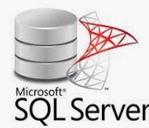  



**Hierarchy ToolDb**

**QL/FT /H21_DW Organisation Hierarchies**

**QL/FT /H21_DW Finance Hierarchies**

**Ql/FT User Business Units**

**QL User Creation/Work Groups**

**FT User Property**

**SharePoint User Groups(DW)**

Load  **Load Load Load**

QL  **FT H21 DW DW**

**Source Databases:**

**Db Name: RL**

**Higher Level Description of Source Extract: Employee ,Ql User Creation,User Work groups, UserBusinessUnits,UserProperty,Organisation Hierarchy**

**Db Name: Hierarchy tool DB**

**Higher Level Description of Source Extract: Finance Hierarchies (Nominal,Activity,Company)**